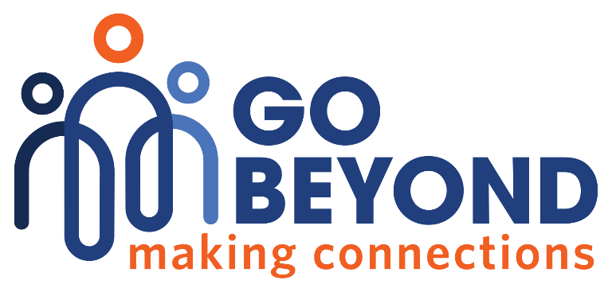

Donation Receipt
Date: 04/28/2025
Donation Amount:
Received From:
Check Number:

Go Beyond empowers students, educators, and business people from diverse backgrounds to learn, connect, and inspire each other to create a brighter future.

Thank you for your generous donation! Your support makes a real difference in the lives of those we serve.

3445 Winton Place
Rochester, NY 14623
EIN: 93-4185219
585-272-0110
www.gobeyondrochester.org
Our organization is registered as a 501(C)(3).

